
SUBJECT:
SOFTWARE C&D
4TH

LAB TASK:
MR MUHAMMAD EJAZ
SUBMITTED TO:
AFTAB GHANI
SUBMITTED BY:
DEPARTMENT:
SOFTWARE ENGINEERING
CU ID:
4329-2023

SEMESTER:
5TH
DATE:
02-01-2026

CECOS UNIVERSITY OF IT & EMERGING SCIENCE HAYATABAD, PESHAWAR

LAB 04
1. WAP to print the squares of numbers from 1 to 10 using a for loop.
Code:
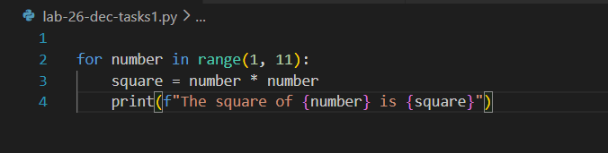
Output:
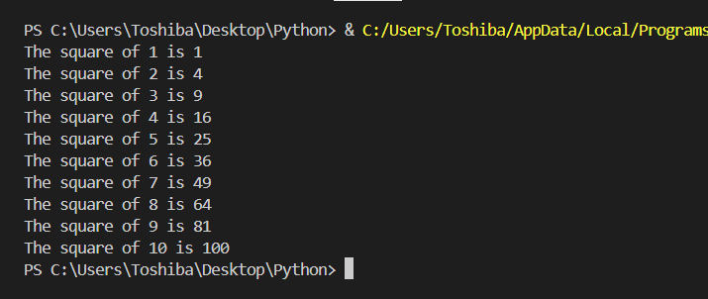
2. WAP to iterate through a string and count how many vowels it contains.

Code:
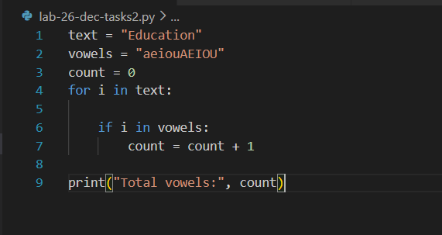
Output:
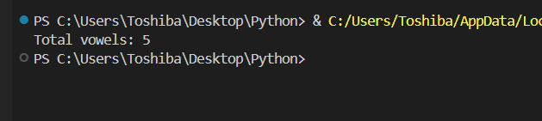
3. Given a list of marks, print only the marks greater than 50 using a for loop.
Code:
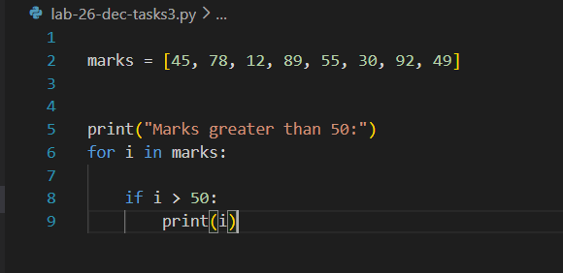
Output:
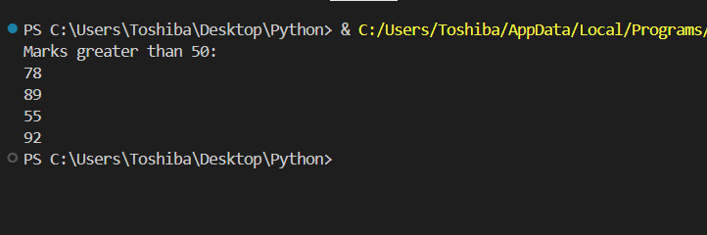
4. WAP using while loop to print all odd numbers between 1 and 20.
Code:
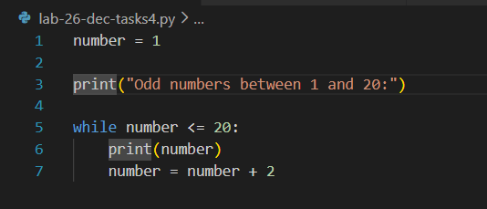
Output:
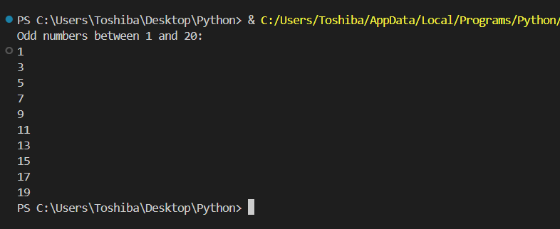
5. WAP to repeatedly ask for a password until the user enters the correct one.
Code:
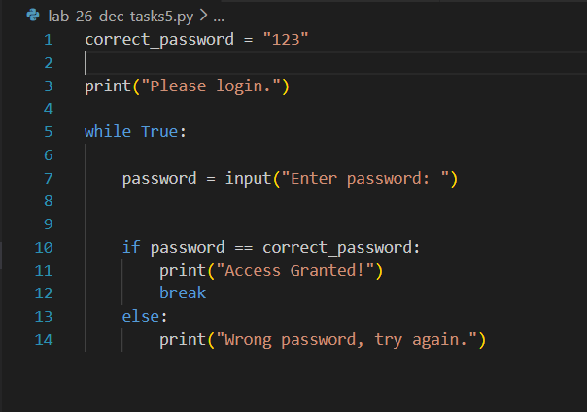
Output:
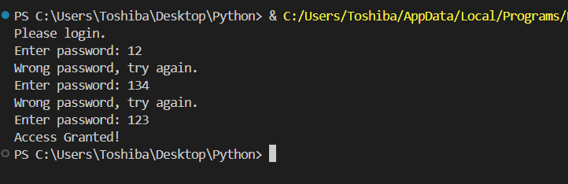

6. Keep taking input from the user until they type “stop”.
Code:
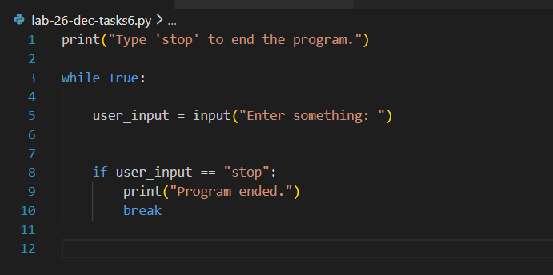
Output:
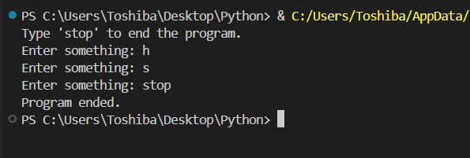

7. Calculate the sum of numbers from 1 to n.
Code:
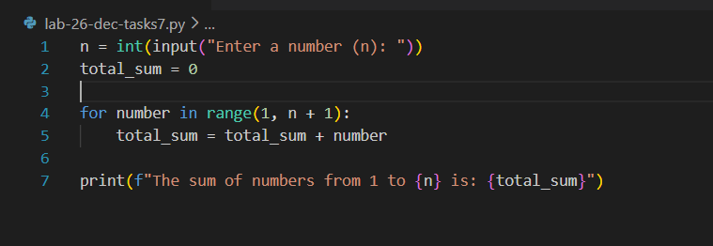

Output:
